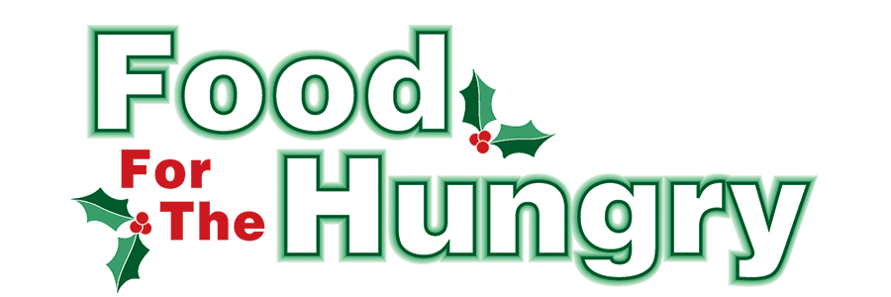

**PRESS RELEASE**

**Contact Olivia Greenich Stern  
Food For The Hungry Digital Content & Marketing Director  
(330) 260-4059  
Contact@FoodForTheHungryCares.org**

**December 5, 2024**

**FOR IMMEDIATE RELEASE**

**HEADLINE: Fire and Ice returns at Honey Run Waterfall**

MOUNT VERNON — The Knox County Park District and the Millwood Church of Christ have teamed up again to bring back Fire and Ice to the Honey Run Waterfall! After a year hiatus, this special event will be held on Saturday, December 14 from 5:30 pm - 8:30 pm, and will help wrap up the 2024 Food For The Hungry Drive. Those wanting to experience the waterfall event must park at the Millwood Church of Christ, located at 10900 Millersburg Road (US 62) in Howard. There will be no on-site parking at the waterfall. The Millwood Church of Christ has a very spacious, well-lighted parking lot. In the church parking lot, there will be volunteers at designated sites, accepting monetary and canned/boxed food donations to benefit the Food For The Hungry campaign.

From the church parking lot, guests can hop a KAT shuttle for a short ride to the waterfall to experience hundreds of luminarias which magically guide guests along the Honey Run Waterfall trails to the waterfall and river. The event has been touted as a “spectacular event” at one of Knox County’s natural gems, the Honey Run waterfall. The waterfall cascades 25’ over the geologically significant blackhand sandstone and will be lit just for the Fire and Ice event. Be sure to catch this must-see natural wonder in a whole new “light,” and during a unique season of the year. Also keep friends, neighbors, and those in need close in thought and heart and bring an outpouring of monetary and food donations to benefit Food For The Hungry!

Follow FFTH on Facebook (@FoodForTheHungryKnoxCounty) and Instagram (@FFTHCares) to stay up to date on all things FFTH. Get involved by attending events, donating, volunteering, or even hosting your own event for FFTH! If you are hosting an event or collection, make sure to fill out the Community Event/Collection Form on the FFTH website.

To learn more about FFTH, donate, or find photos, videos, and more, visit [www.FoodForTheHungryCares.org](http://www.foodforthehungrycares.org). To volunteer with FFTH, call or text Kathy Brechler at (740)-409-1866 or email Director@FoodForTheHungryCares.org.

The 2024 FFTH Live Broadcast will take place on Friday, Dec. 13 at the Memorial Theater inside the Knox Memorial. This is a Knox County tradition you won’t want to miss!

***Food For The Hungry—Working together to care for our neighbors.***

###