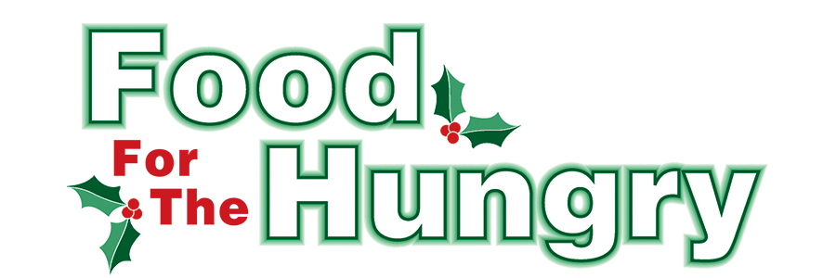

**PRESS RELEASE**

**CONTACT: Olivia Greenich Stern  
Food For The Hungry Marketing and Digital Content Director  
330-260-4059  
Wednesday, March 26, 2024**

**FOR IMMEDIATE RELEASE**

**HEADLINE: Food For The Hungry offers Summer Grant opportunities for Summer distribution programs**

MOUNT VERNON — The Food For The Hungry board has announced a Summer grant opportunity directed to reach churches, agencies, and organizations that provide Summer food distribution programs to fill the gap for families with children home from school. Thanks to the outstanding generosity of Knox County, the funds raised during the 2024 FFTH Drive Season totaled $342,459.11. The FFTH board has designated $26,000 of the collection for Summer grants.

On March 18th, 15 people representing nine organizations and FFTH Board members Marcy Rinehart, Michele Corsica, Lisa Lloyd, Austin Swallow, and Executive Director Kathy Brechler met to discuss ways FFTH could work closer with the organizations it funds through the grant process. The goal of the meeting was to ensure that FFTH grants are being utilized effectively to serve those in need of food within Knox County. There was collaborative and productive discussion amongst the organizations as they shared ideas of what worked with the grant process and how they could contribute to each other’s efforts to help those in need in our county. All who attended attested that the session was worth attending and agreed to meet again in the Fall.

One request of the discussion was for the Summer grant application to be open earlier and longer than in previous years. In response to this request, the application process will be open from **Tuesday, April 1**, through **Wednesday, April 30, at 12 p.m**. Awards will be announced in late May/early June. The online application is available at FoodForTheHungryCares.org.

Organizations may apply for a FFTH Summer Grant for programs that will provide food assistance and distribution through the Summer months until Sept 30, 2025. Priority will be given to programs that assist youth who rely on meals provided by schools during the school year. However, groups that provide assistance outside the traditional Mid-Ohio Food Collective income guidelines are strongly encouraged to apply. All other food initiative organizations are also welcome to submit an application.

For more information or assistance on the grant application and process, please email FFTH Executive Director Kathy Brechler at Director@foodforthehungrycares.org.

For photos, videos, and radio interviews from the 2024 drive, as well as FFTH history and continued opportunities to donate, please visit www.FoodForTheHungryCares.org. The 2024 Drive broadcast is available on demand for a full year at [www.mvnu.tv](http://www.mvnu.tv).

Thank you to this generous community and continued support as we ***work together to care for our neighbors.***

###