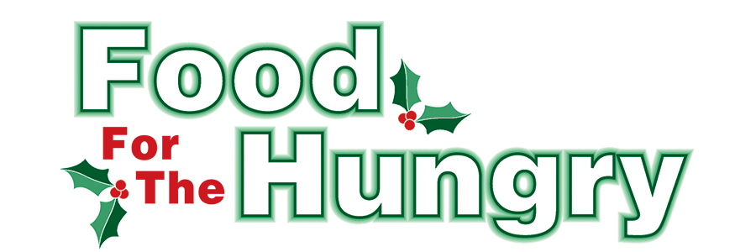

**FOR IMMEDIATE RELEASE**

**Contact Olivia Greenich Stern  
Food For The Hungry Digital Content and Marketing Director  
(330) 260-4059  
oligreenich@gmail.com**

**NOV 4, 2024**

**FOR IMMEDIATE RELEASE**

**HEADLINE: Knox Public Library marks 36 years of supporting Food For The Hungry**

MOUNT VERNON — 2024 marks the 36th year of The Knox County Public Library campaigning for Food For The Hungry (FFTH). As this tradition continues, the Libraries of Knox County will be collection points for Food For The Hungry donations from **November 4** - **December 13.** Library branches participating include Danville Public Library, Fredericktown Community Library, Gambier Community Library, and the Public Library of Mount Vernon and Knox County. The libraries will be collecting non-perishable food items, monetary donations for FFTH, and care items/food for dogs and cats for the Humane Society.

A new addition to the FFTH Library Drive is a raffle. Patrons that bring in three items to donate per visit will get a raffle ticket for a Gift Card Give-Away. Raffle will end December 13 at noon. Patrons can enter the raffle each time they bring three donation items to their Knox County Library. The more a person donates, the more chances the patron has to win a gift card!

The top ten food items needed are soup (pop-top cans or packages), jelly, canned meals (ravioli, spaghettios, ect.), breakfast foods (cereal, oatmeal, pancake mix), canned fruit, canned vegetables, pasta/egg noodles, side dishes (boxed or packaged), peanut butter, and pasta sauce. Cans that can be opened without a can opener (pop top) are best.

Non-perishable items that are at or near their expiration dates, damaged, or in compromised containers will not be accepted. All collected food and money will be given to the 2024 Food For The Hungry Drive. Donations from each community will stay in that local community.

Follow FFTH on Facebook (@FoodForTheHungryKnoxCounty) and Instagram (@FFTHCares) to stay up to date on all things FFTH. Get involved by attending events, donating, volunteering, or even hosting your own event or collection for FFTH! If you are hosting an event, make sure to fill out the Community Event Form on the FFTH website.

To learn more about FFTH, donate, or find photos, videos, and more, visit [www.FoodForTheHungryCares.org](http://www.foodforthehungrycares.org). To volunteer with FFTH, call or text Kathy Brechler at (740)-409-1866 or email at *Director@FoodForTheHungryCares.org*. The 2024 FFTH Live Broadcast will take place on Friday, Dec. 13 at the Memorial Theater inside the Knox Memorial. This is a Knox County tradition you won’t want to miss!

***Food For The Hungry—Working together to care for our neighbors.***

###