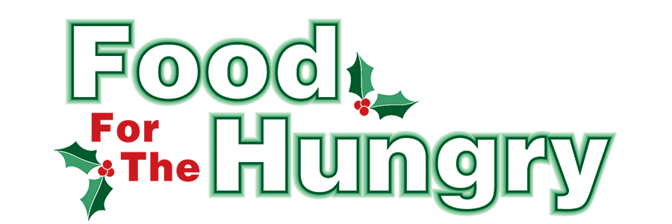

**PRESS RELEASE**

**Contact Olivia Greenich Stern  
Food For The Hungry Digital Content and Marketing Director  
(330) 260-4059  
contact@foodforthehungrycares.org**

**NOV 14, 2024**

**For Immediate Release**

**HEADLINE: Food For The Hungry Awards $35,500 in Winter Grants**

MOUNT VERNON, OHIO—The annual Food For The Hungry Drive officially kicked off on Nov. 1, as a community-wide effort to raise food and funds for Interchurch Social Services, The Salvation Army, and other organizations throughout the county with food assistance initiatives. In Food For The Hungry’s (FFTH) 43rd year of helping the community, it has established a financial **Drive Goal of $330,000** and hopes to collect as many non-perishable food items as the community can donate.

Food for the Hungry is a nonprofit organization focused on providing food and financial support to entities striving to reduce hunger in Knox County. To accomplish this mission, there is a food and money drive made up of multiple events culminating into a one-day simulcast (broadcast online and via the radio) on the second Friday of December. The 2024 Drive will take place on December 13, from 9 A.M. to 4 P.M..

Funds from the 2023 FFTH Drive were allocated for this year's Winter Grants that will enable local organizations to provide food to those in need through the 2024-2025 Winter. To assess the community's needs, FFTH opened its Winter Grant Application from September 18-30 and received an exceptional response. Each organization was able to express its particular needs. After careful review of the applications by the FFTH grant committee, **FFTH is honored to award a total of $35,500 in grant funds to 16 different organizations!** The grant recipients are as follows:

***Alcohol & Drug Freedom Center Knox County - $1,500***

***Central Christian Church Food Pantry - $3,500***

***CHOMP Free Fresh Produce Market - $2,500***

***Church on the Rise Food Pantry - $3,500***

***Covenant Church Food Pantry - $3,500***

***Escape Zone - $2,500***

***Gay Street United Methodist Church Hot Meals - $2,500***

***Knox County Career Center - $2,500***

***Knox County Task Force For Older Adults - $1,500***

***Knox Educational Service Center - $2,500***

***Knox County Head Start - $2,000***

***LifePointe Church - $2,500***

***Millwood Church of Christ Sharing Shed - $1,500***

***Mount Vernon Association of Police Chaplains - $500***

***TouchPointe Marriage and Family Resources - $1,500***

***Winter Sanctuary Emergency Homeless Shelter - $1,500***

The recipients will use their grants for food initiatives that range from food pantries to weekend meal assistance for students. Each recipient will be recognized during the 2024 FFTH Live Broadcast that will take place on Friday, Dec. 13 from 9 A.M. to 4 P.M. at the Memorial Theater inside the Knox Memorial. FFTH Live will be available on 100.9 FM and 93.7 HD2 - WMVO, with video stream at [www.mvnu.tv](http://www.mvnu.tv/) and the FFTH Facebook page. Updates will be given throughout the day on 90.9 WNZR, 93.7 The Super Q, and FFTH social media. This is a Knox County tradition you won’t want to miss!

Follow FFTH on Facebook (@FoodForTheHungryKnoxCounty) and Instagram (@FFTHCares) to stay up to date on all things FFTH. Get involved by attending events, donating, volunteering, or even hosting your own event for FFTH! If you are hosting an event or collection, make sure to fill out the Community Event Form on the FFTH website.

To learn more about FFTH, donate, or find photos, videos, and more, visit [www.FoodForTheHungryCares.org](http://www.foodforthehungrycares.org). To volunteer with FFTH, call or text Kathy Brechler at (740)-409-1866 or email at *Director@FoodForTheHungryCares.org*.

***Food For The Hungry—Working together to care for our neighbors.***

###