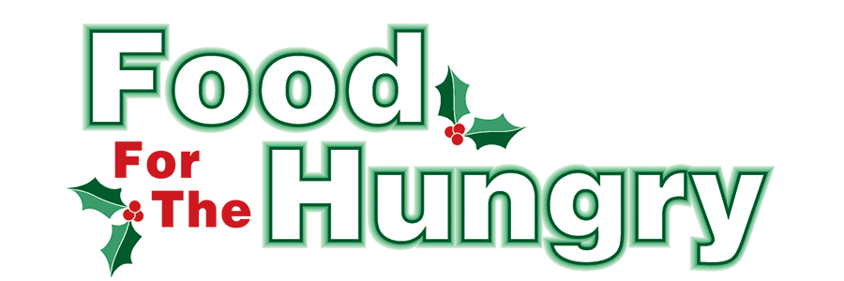

**PRESS RELEASE**

**Contact Olivia Greenich Stern  
Food For The Hungry Digital Content & Marketing Director  
(330) 260-4059  
oligreenich@gmail.com**

**NOV 7, 2024**

**FOR IMMEDIATE RELEASE**

**HEADLINE: Service Clubs Annual Friendly Competition to Support 43rd Food For The Hungry Campaign**

MOUNT VERNON —Local service clubs across Knox County are invited to participate in the annual Friendly Competition to raise funds for the 43rd Food For The Hungry (FFTH) Campaign, with a goal to reach $330,000 to support families in need during the holidays and throughout the year. The campaign, organized by Food For The Hungry, aims to provide essential food assistance to community members facing hunger in Knox County.

Through this exciting and collaborative effort, service clubs have the unique opportunity to help multiply their impact: for every $1 donated, it equals $4.56 in buying power at the Mid-Ohio Food Collective, allowing donations to stretch further and feed more people in need.

"We're incredibly excited to see the community come together once again to support this important cause," said Kathy Brechler, Director of Food For The Hungry. "This is a great way for local clubs to make a direct impact on families in Knox County, especially during the holiday season when so many are struggling."

How to Participate:

1. Start Collecting Funds Today: Clubs can begin collecting donations immediately. The collection period runs through December 9, 2024.
2. Submit Your Funds: Deliver your donations in an envelope clearly marked with your organization’s name and indicating that the funds are for Food For The Hungry to WRP CPAs, located at 1684 Venture Drive, Suite B, Mount Vernon.
3. Recognition and Live Broadcast: All participating clubs will be recognized during the Food For The Hungry LIVE event, broadcast on December 13, 2024. The club that raises the most funds will have the opportunity to send a representative to be featured on the live broadcast at the Memorial Building.

This Friendly Competition offers a fantastic opportunity for service clubs to support the community while also fostering a sense of camaraderie and purpose during the holidays.

Let’s work together to help end hunger in Knox County!

Follow FFTH on Facebook (@FoodForTheHungryKnoxCounty) and Instagram (@FFTHCares) to stay up to date on all things FFTH. To learn more about FFTH, donate, or find photos, videos, and more, visit [www.FoodForTheHungryCares.org](http://www.foodforthehungrycares.org). To volunteer with FFTH, call or text Kathy Brechler at (740)-409-1866 or email Director@FoodForTheHungryCares.org.

FFTH LIVE begins on Friday, Dec. 13 at 9 A.M. and continues until 4 P.M. FFTH LIVE will be available on 100.9 FM and 93.7 HD2 - WMVO, with video stream at [www.mvnu.tv](http://www.mvnu.tv/) and the FFTH Facebook page. Updates will be given throughout the day on 90.9 WNZR, 93.7 The Super Q, and FFTH social media. FFTH LIVE will air from the Memorial Theater in Knox Memorial on East High Street in Mount Vernon.

This is a Knox County tradition you won’t want to miss!

***Food For The Hungry—Working together to care for our neighbors.***

###